JVS2
Test Automation Guidelines

 | Version: | 0.2
 | Issuer: | Peter Nordlander
 | Date: | 2007-07-06

Revision History
Date | Version | Description | Author
2007-05-03 | 0.1 | Initial version | Björn Beskow
2007-07-06 | 0.2 | Updated based on feedback from Zoo | Björn Beskow

Table of Contents
1. Introduction 4
1.1 Purpose 4
1.2 Scope 4
1.3 Definitions, Acronyms and Abbreviations 4
1.3.1 Acronyms 4
1.4 References 4
2. Different types of automated tests 4
2.1 Unit Tests 4
2.2 Integration Tests 4
2.3 System Tests 5
2.4 Performance/Load Tests 5
2.5 Ratio between Unit/Integration/System Tests 5
3. Unit Tests 6
3.1 Naming Conventions 6
3.2 Source code organization 6
3.3 Typical JUnit test scenario 6
3.4 Setting up test data 7
3.5 Handling Exceptions 7
3.6 Mock tests 7
3.6.1 Typical EasyMock configuration 8
3.6.2 Typical Mock Object usage 8
4. Integration Tests 9
4.1 Naming Conventions 9
4.2 Disabling execution of Integration Tests in Maven 9
4.3 Protecting Test Data using transaction demarcation 9
4.4 DbUnit tests 10
4.4.1 DbUnit test data 10
4.4.2 Database connections 10
4.4.3 NULL values in test data 11
4.4.4 Comparing result datasets 11
4.4.5 Ordering tables in a DbUnit dataset 11
5. System Tests 12

Test Automation Guidelines

Introduction

Purpose
This document describes principles and practices for writing and executing Unit, Integration and System tests.

Scope
The scope of this document is the JVS2 project.

Definitions, Acronyms and Abbreviations

Acronyms

References
Applicable references are:
- JVS Test Data Guidelines
- JUnit: www.junit.org
- EasyMock: www.easymock.org
- DbUnit: www.dbunit.org

Different types of automated tests
A system can be tested from different aspects and at different levels of granularity. Hence tests can be of very varying shape, ranging from white-box testing of a tiny component to black-box testing of a use-case of the system as a whole to performance and load testing.
Many different names have been used for different types of tests (class tests, integration tests, system tests, functional tests, …), and no real consensus exists with regards to terminology. For this purpose, we will only distinguish between four types of tests: Unit Tests, Integration Tests, System Tests and Performance/Load Tests.

Unit Tests
A Unit Test is any test which tests a logical unit in isolation. Unit Tests thus may be either white-box (i.e. testing internal implementation details) or black-box (testing only the unit from the outside in terms of inputs and outputs). Unit Tests are written and executed by developers as part of the development process. Unit Tests are written in a programming language, ideally in the same language as the production code.
Once written, Unit Tests always must run 100% correct at all times before integrating any changes.

Integration Tests
An Integration Test is any test which tests a logical unit together with other units that it depends on, such as other software units but more frequently external resources such as Databases or Message Queues. Thus the integration tests share many of the characteristics of Unit Tests, but the granularity is much bigger. Due to the performance costs in accessing external resources, the integration tests usually takes much longer time to execute.

System Tests
A System Test is a test which tests a system or part of a system from the outside, in terms of observable behavior. System Tests are typically structured around a comprehensible chunk of system functionality (Use Cases, Stories, Features or whatever the methodology used likes to call it).
System Tests are ideally written by Customers (or their representatives, such as Business Analysts), and express expectations on the functionality and usage of the system. Automated System Tests are either written in terms of User Interface actions, or against a testability API. They are written as “words” and “facts” which makes sense from a Business perspective, which are given formal semantics by a the FIT Framework. Automated System Tests ideally run near 100% correct at the end of an iteration/project.

Performance/Load Tests
Performance and Load tests are currently outside the scope of this document.

Ratio between Unit/Integration/System Tests
Unit tests are naturally the most efficient way of catching defects on the Unit level. If a defect can be caught using a Unit Test, it should therefore be preferred instead of catching it using an Integration test. Hence there will typically be many more Unit tests than integration tests. Integration tests should be used for testing interaction between units and between units and external resources.
System Tests and Unit/Integration tests are driven from different contexts, and are typically structured differently (unit and integration tests are structured after the implementation model, whereas system tests are structured after the requirements model). An overlap (and hence redundancy) between Unit/Integration and System tests are healthy, providing different angles to testing the functionality.

Unit Tests
Unit Tests are written using the JUnit framework.

Naming Conventions
Unit Tests should be named after the Unit that is tested, with "Test" appended. Thus if the Unit under Test is named ComponentXImpl, the corresponding JUnit test should be named ComponentXImplTest.

Source code organization
JUnit Tests should be placed within the same Java package as the Unit under Test, but in a different directory structure. Production code in placed in the folder src/java, while test code is place in the folder test/java.
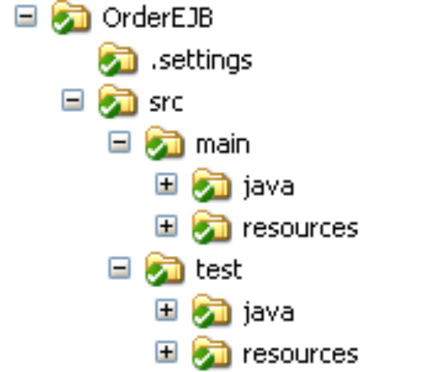
That makes it possible to test functionality with package accessibility, while still making it easy to separate out test code from production code.

Typical JUnit test scenario
A typical unit test follows the “three A” pattern: Arrange-Act-Assert:
- Arrange: Instantiate the Unit under Test, and set up its state. Create any test data objects needed.
- Act: Call one or more methods on the Unit under Test, providing the test data objects as parameters.
- Assert: Verify the results returned by the Unit under Test are correct.
The following provides an example:
public class AccountImplTest {
@Test
public void testWithdraw() {
AccountImpl account = new AccountImpl(“1234-9999”, 2000); //Arrange
account.withdraw(300); //Act
assertEquals(1700, account.balance()); //Assert
}
}

Setting up test data
Test data common to several test scenarios should be reused to minimize redundancy. The @Before setUp() and @After tearDown() template methods should be used to establish the test data instances and clean them up respectively. The JUnit framework guarantees that setUp() and tearDown() is executed prior to and after each test method, which gives every test method fresh test data to work with. Test data should hence not be created in the constructor of the Test class.

Handling Exceptions
Unexpected exceptions thrown during execution of a test will be caught by the JUnit framework and reported as Errors. Hence a Test method must declare that it throws any checked exceptions that the Unit under Test may throw, which should signal an error. If there are several checked exceptions that may occur, it is perfectly valid for a test method to declare throwing java.lang.Exception.
Expected exceptions (exceptions that the test is expecting the Unit under Test should throw in a certain situation) are expressed using the following idiom:
try {
unitUnderTest.doSomethingNasty();
fail("NastyException expected");
} catch (NastyException expected) {
// Expected
}
The expected exception is thus caught by the unit test. In case the correct exception is not thrown by the Unit under Test, the fail call will explicitly make the test fail (since it does not meet the expectations of the test).

Mock tests
Mock Objects are used to break up a dependency between a Unit Under Test and some other object that the Unit Under Test depends on. The Mock Object thus provides a "fake" implementation as a stand-in for the dependent object. In the example below, the Unit Under Test has a dependency to a Data Access Object. By providing a Mock object for this Data Access Object, the Unit Under Test can be tested in isolation, without the DaoImpl.
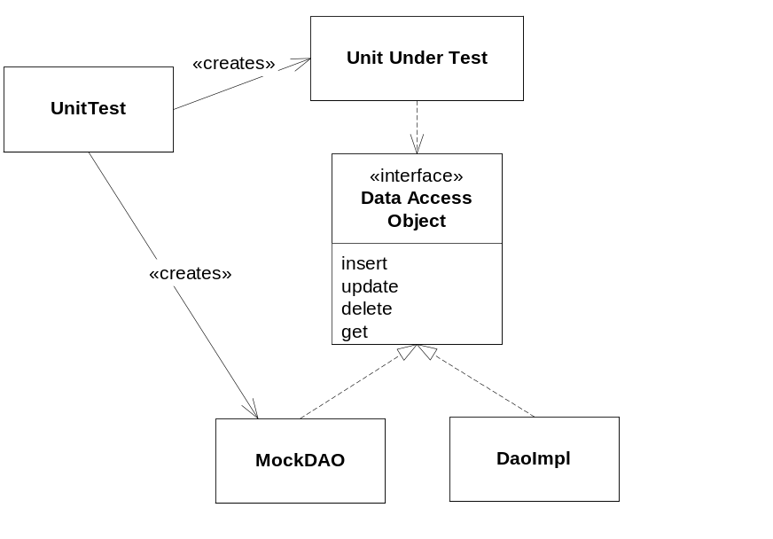
EasyMock is used to construct Mock objects.

Typical EasyMock configuration
- Create Mock Object
- In ”record mode”, use the Mock Object to record expected usage
- Use the associated control object to specify return values, exceptions, call counts.
- Enter ”playback mode” to use the Mock Object within the test
The following is an example:
import org.easymock.EasyMock;
MyInterface mock = EasyMock.createMock(MyInterface.class);
// Record expected call and specify return value
EasyMock.expect(mock.myMethod(5)).andReturn(”five”);
// Record expected call and specify exception to be thrown
EasyMock.expect(mock.myMethod(-1)).andThrow(new Exception());
// Record phase done, enter playback mode
EasyMock.replay(mock);

Typical Mock Object usage
- Instantiate the Mock Objects
- Set up state in the Mock Objects, which govern their behavior
- Set up expectations on the Mock Object
- Execute the method(s) on the Unit Under Test, using the Mock Objects as resources
- Verify the results
- Verify the Mock Object expectations
The following provides an example:
import org.easymock.EasyMock;
// Set up state and expectations on Mock Objects
MyInterface mock = EasyMock.createMock(MyInterface.class);
EasyMock.expect(mock.myMethod(5)).andReturn(”five”);
EasyMock.replay(mock);
// Connect mock object with unit under test
unitUnderTest.setDependee(mock);
// Exercise unit under test
unitUnderTest.doSomething();
// Verify mock object expectations
EasyMock.verify(mock);

Integration Tests
The difference between Unit and Integration Tests is mostly a matter of granularity. Hence JUnit is used both for Unit and Integration Tests. Since the runtime characteristics are so different (where Integration Tests involving Database access may take several magnitudes more time to execute), it is important to be able to distinguish them.

Naming Conventions
Integration Tests should be named after the Unit or Subsystem that is tested, with "IntegrationTest" appended. Thus if the Unit under Test is named ServiceXImpl, the corresponding Integration test should be named ServiceXImplIntegrationTest.

Disabling execution of Integration Tests in Maven
To disable the inclusion of Integration Tests in the 'test' phase of Maven, specify the property maven.itest.skip=true, as in
C:\> mvn –Dmaven.itest.skip=true install
This is done by all external tool builders running Maven within Eclipse/RAD.

Protecting Test Data using transaction demarcation
Since integration tests may involve usage of "external" resources such as Databases or Message Queues, it is of vital importance to protect the data consistency. The integration tests must not have any persistent side effects on e.g. the contents of a Database table, since the test must be repeatable. Integration tests can also be executed by several developers concurrently, so any temporary changes made to e.g. a database must not be visible to other, concurrent test runs.
A workable solution is therefore to use the underlying transaction management to isolate integration tests: The test starts a transaction in setUp(), and rolls back the transaction in tearDown(). This mechanism guarantees that any changes to e.g. a database will be rolled back, leaving the database in the same state as before. It also isolates the changes done during the test execution from other concurrent test runs (assuming an isolation level of at least "Read Committed").
This pattern is so frequent, that the JVS TestSupport library provides two base classes for this purpose:
- AbstractTransactionalTestCase
- AbstractTransactionalDbUnitTestCase
A transaction is started in the @Before setUpTransaction() method and rolled back in @After tearDownTransaction(), which are therefore made final (to avoid unintentional override).
The following example illustrate the usage:
public class CustomerServicesIntegrationTest extends AbstractTransactionalTestCase {

@Before
public void setUpData() throws Exception {
// Do initial setup of data here
}

@Test
public void testSomethingDestructive() {
// Tests which modify data doesn’t have to care about cleaning up
}
}

DbUnit tests
Integration tests involving database resources often needs to specify expectation on the raw database contents after a method on the Unit under Test has been executed. It is not uncommon for such tests to also specify initial data that should be present before the method on the Unit under Test is executed.
DbUnit provides support for these and similar scenarios.
A more thorough discussion on Test Data can be found in [1].

DbUnit test data
Test data for initial insertion or for result comparison are specified as DbUnit Datasets in XML format. They can be provided either in separate XML files or as inlined XML strings. The JVS TestSupport library provides two base classes for creating Datasets:
- AbstractDbUnitTestCase
- AbstractTransactionalDbUnitTestCase
The following example shows how to create a DbUnit dataset from an XML file read from the Classpath:
private static final String INITIAL_DATA_FILE =
"dbunit/dbunit_testdata.xml";
public void testUpdate() throws Exception {

IDataSet dataSet = getDataSet(getReader(INITIAL_DATA_FILE));
DatabaseOperation.INSERT.execute(getDbunitConnection(), dataSet);

...
}
The following example shows how to create an inlined DbUnit dataset:
private static final String INITIAL_DATA =
"<?xml version='1.0'?>"
+ "<dataset>"
+ " <AREA AREA_ID='1000' NAME ='testParent' AREA_TYPE_ID ='1'"
+ " PARENT_AREA_ID ='[NULL]' Version ='2' />"
+ " <AREA AREA_ID='1001' NAME ='testChild' AREA_TYPE_ID ='1'"
+ " PARENT_AREA_ID ='1000' Version ='1' />"
+ "</dataset>";

public void testInsert() throws Exception {

IDataSet dataSet = getInlinedDataSet(INITIAL_DATA);
DatabaseOperation.INSERT.execute(getDbunitConnection(), dataSet);

...
}
Using inlined test data makes the tests more self-describing and modular, but may also introduce redundancy between tests. It is thus a judgment call when to inline DbUnit data, and when to break it out into a separate XML file.

Database connections
DbUnit tests should use the same DataSource as the Unit under Test, in order for the Transaction Demarcation pattern to work. The AbstractDbUnitTestCase provides a convenience method for acquiring a DbUnit connection object from an underlying DataSource.

NULL values in test data
When using flat XML DbUnit datasets, DbUnit does not out-of-the-box handles NULL values. Special conventions must therefore be used to be able to specify NULL values in dataset. The getDataSet and getInlinedDataSet convenience methods transforms the special string "[NULL]" into a NULL value, as exemplified in the previous example.

Comparing result datasets
When comparing an expected DbUnit dataset with an actual dataset, typically only the columns present in the expected dataset should be used in the comparison. The DbUnitAssert class provides a convenience methods which applies the appropriate filter to only consider the columns from the expected dataset. The following code snippet exemplifies its usage:
IDataSet expectedDataSet = getInlinedDataSet(EXPECTED_DATA);
ITable expectedTable = expectedDataSet.getTable("area");

IDataSet actualDataSet = getDbunitConnection().createDataSet();
ITable actualTable = actualDataSet.getTable("area");

DbUnitAssert.assertEquals(expectedTable, actualTable);

Ordering tables in a DbUnit dataset
When inserting rows into tables, the ordering between tables may be important due to RI constraints in the database. The AbstractDbUnitTestCase and AbstractTransactionDbUnitTestCase base classes provides a convenience method which queries the database for metadata describing the RI constraints, and reports on an ordering between tables which is consistent with the RI constraints. The report is produced on the standard out:
...
reportOrder(INITIAL_DATA);
...

System Tests
[To be completed]

